Section 11.1
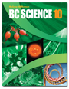
Natural Causes of Climate Change
Check Your Understanding

Checking Concepts

1. Define the term “climate.”

2. What is the term for scientists who study past climates?

3. List three reasons for natural climate changes on Earth.

4. Name two factors that affect the amount of solar radiation reaching Earth’s surface.

5. Name a gas that is important in the natural greenhouse effect.

Understanding Key Ideas

6. What types of evidence do paleoclimatologists use to study ancient weather patterns?

7. What features are used to describe a biogeoclimatic zone?

8. What is the main difference between an El Niño event and a La Niña event?

9. Uranus is a planet that is tilted on its side at about 90°. Explain how the climate would change in your region of British Columbia if Earth were tilted:

(a) 90° toward the Sun

(b) 90° away from the Sun

10. Earth wobbles as it spins on its axis. How might wobble affect climate?

11. Suppose all the continents were grouped together in one giant landmass. How would this grouping affect heat transfer by the oceans?

12. How could the impact of a large meteorite influence global climate?

13. How does the shape of Earth’s orbit around the Sun affect Earth’s climate? Draw diagrams to help explain your answer.

14. Suppose you are analyzing an ice core. You find that the amount of CO2 trapped in the ice core decreases with increasing depth. What would this observation suggest about changes in Earth’s atmosphere over time?

15. Use the diagram of Earth shown below to answer these questions.

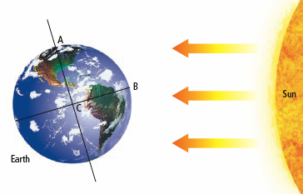

(a) What season is it in the region indicated at A?

(b) Where do the Sun’s rays reach Earth at an angle of incidence of 0°: A or B? Explain your answer.

(c) Which region receives the most direct solar radiation?

(d) Which regions have the most similar climates: A and B, B and C, or A and C? Explain your answer.



Paleoclimatologists have found that Earth’s climate has gone through several periods of warming between ice ages. Based on studies of ice cores, scientists think that levels of CO₂ in the atmosphere were higher during periods of warming and lower during ice ages. What factors could have caused Earth’s climate to warm and then cool?

