Section 10.2
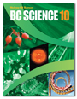
Energy Transfer in the Atmosphere
Check Your Understanding

Checking Concepts

1. Name the two chemical elements that make up most of Earth’s atmosphere.

2. In which layer of the atmosphere do people live?

3. What is atmospheric pressure?

4. What does a barometer measure?

5. What term is used for the amount of water vapour carried in air?

6. What does the Coriolis effect do to winds in the northern hemisphere?

7. What causes jet streams?

8. What is the name for the boundary between air masses?

9. What is the difference between a tornado and a hurricane?

10. Use a Venn diagram to compare “insolation” and “albedo.”

Understanding Key Ideas

11. Hot air rises. Why is it that the atmosphere does not get hotter with increasing height? (Hint: The explanation is related to the reason why mountain climbers often need to use oxygen tanks.)

12. Explain the role of photosynthetic microorganisms in the composition of Earth’s atmosphere.

13. Explain why 75 percent of the atmosphere’s mass is found in the troposphere.

14. Venus and Earth are planets of equal size. The atmosphere of Venus is half the thickness of Earth’s atmosphere. Why is the atmospheric pressure at the surface of Venus nearly 100 times greater than atmospheric pressure at the surface of Earth?

15. Why do passenger airplanes often fly just above the troposphere?

16. Explain why sea breezes occur.

17. What factors affect the amount of insolation at Earth’s surface?

18. Refer to the weather map below to answer the following questions.

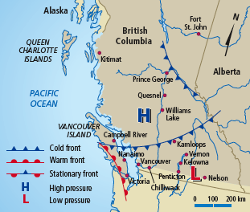

(a) Based on the weather map and the fronts shown, what season do you think it is? Justify your response.

(b) Which direction would you expect the winds to be blowing in Kelowna? Explain.

(c) What type of weather front is approaching Victoria?

(d) Should people in Vernon expect cold or warm weather? Explain.

19. If Earth’s oceans were to heat up, how might this affect the atmosphere over the tropics?



You may have heard the old joke “everybody complains about the weather, but nobody does anything about it.” If you had super powers that allowed you to do something about the weather, what conditions in the atmosphere would you have to control?

