Section 10.1
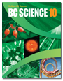
Temperature, Thermal Energy, and Heat
Check Your Understanding

Checking Concepts

1. Complete the following question. Match the term in column A with the correct description in column B.

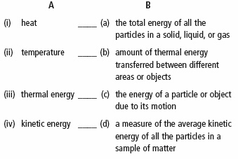

2. Name the correct temperature scale (Fahrenheit, Celsius, or Kelvin) for each of the following values. The values are the temperatures at absolute zero (the temperature at which all particle motion stops).

(a) 0°

(b) –273°

(c) –460°

3. Create a table to compare and contrast the transfer of heat by conduction and convection. Use the following headings in your table.

• States of Matter Involved
• Examples of Materials Involved
• How Particles Interact
• What Is Transferred?

4. If you leave lights on in a closed room, the air inside the room will start to feel hot. What type of energy transfer is involved in this situation? Explain.

5. What part of the electromagnetic spectrum makes the sidewalk feel warm on a sunny day?

Understanding Key Ideas

6. Explain how thermal energy is transferred from a hot stove element to soup in a pot. Refer to the motion of atoms and molecules in your response.

7. Can conduction occur between a hot beaker and your hand if you do not touch the beaker? Explain.

8. Suppose you pour some hot water into a sink full of cold dishwater. What could you do to make the water in the sink heat up more evenly? Use the kinetic molecular theory to explain your answer.

9. Why does a house with a snow-covered roof stay warmer inside than it would if there were no snow on the roof?

10. Name the type of heat transfer indicated by each letter in the following photograph.

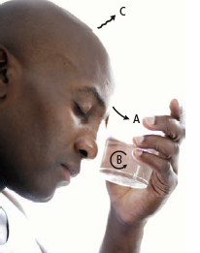



On a hot day, you might have heard someone say that it is “hot enough to fry an egg on the sidewalk!” Explain how radiation and conduction would make this possible.

