Section 8.2

Average Velocity
Check Your Understanding

Checking Concepts

1. Two lines on a position-time graph represent the motion of two world-class sprinters. Line 1 has a steeper slope than line 2. How does the average velocity of the sprinter represented by line 1 compare to the average velocity of the sprinter represented by line 2?

2. What does the slope of the line on a position-time graph represent?

3. What are two common units for velocity?

4. Explain the difference between average speed and average velocity.

5. What is the mathematical relationship between average velocity, displacement, and time interval?

Understanding Key Ideas

6. The motion of two joggers is recorded in the position-time graph below. Calculate the average velocity of jogger A and jogger B.

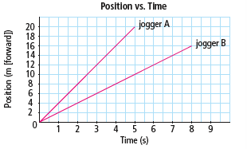

7. Given the position-time graph below, determine which segment of the graph represents each of the following.

(a) zero velocity

(b) positive slope

(c) moving north with a uniform velocity

(d) zero slope

(e) moving south with a uniform velocity

(f) negative slope

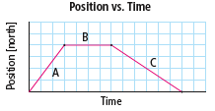

8. What is the average velocity of an arrow that travels 12 m [E] in 0.15 s?

9. What is the average velocity of a snail that crawls 0.25 m forward in 150 s?

10. If a canoe has an average velocity of 4.2 m/s [W], what is its displacement after 25 s?

11. A ball rolls across the floor with an average velocity of 6.0 m/s [S]. What is the ball’s displacement after 12 s?

12. How long does it take to run forward 420 m if the runner’s forward velocity is 6.0 m/s?

13. If sound travels at 350 m/s, how long does it take the sound to travel 110 m across a field?

14. Convert 45 km/h to m/s.

15. A car travels 45 km [N] in 0.70 h.

(a) What is the car’s average velocity in km/h?

(b) What is the car’s average velocity in m/s?

16. A horse is running forward at 42 km/h. What is the horse’s displacement during a 3.0 s time interval?

17. The position of an object is recorded in the following data table.

Time | 0.0s | 2.0s | 4.0s
Position | 3.0m [N] | 7.0m [S] | 3.0m [S]

Calculate the average velocity for each of the following time intervals.

(a) 0.0 s–2.0 s

(b) 2.0 s–4.0 s

(c) 0.0 s–4.0 s



Most major harbours have a 10 km/h speed limit for boats travelling in the harbour. Suppose you are sitting by the harbour and watching the motion of the boats. Describe a simple experiment you could perform to determine if a boat is exceeding the speed limit.

