Section 6.2
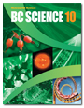
Factors Affecting the Rate of Chemical
Reactions
Check Your Understanding

Checking Concepts

1. Give three examples where it is helpful to have a high reaction rate.

2. Give three examples where it is helpful to have a low reaction rate.

3. What is the function of enzymes?

4. What usually happens to the rate of a reaction when the concentration of one of the reactants is increased?

5. Which has a greater surface area, a single sugar cube or a spoonful of sugar? Explain your answer.

6. How does surface area affect the rate of a reaction?

7. Give an example of a reaction where surface area is not a factor.

8. How does a catalyst speed up a chemical reaction?

Understanding Key Ideas

9. The various factors that affect the rate of a reaction work in different ways at the molecular level. Raising temperature causes molecules to move more quickly, allowing them to hit each other harder and more often. Raising the concentration puts more molecules into the system than were present before. Adding a catalyst helps the molecules to hit with better alignment, making the formation of product more likely.

(a) Which of these factors increase the reaction rate by increasing the number of collisions between reacting molecules?

(b) Which of these factors work by making the collisions between the molecules happen in a more effective way?

(c) Do any of these factors do both?

10. Explain how raising the temperature increases the rate of a chemical reaction.

11. Explain why increasing the surface area in a reaction will increase the rate of the reaction.

12. Explain why increasing the concentration of a reactant will increase the rate of a reaction.

13. Explain how using a catalyst makes it possible for the reaction to happen with less energy than without the catalyst.

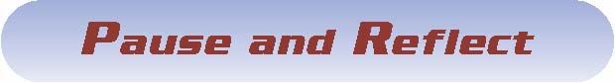

Suppose you have a box full of wrapped chocolates. Whenever you unwrap a chocolate to eat it, you throw the wrapper back into the box.

(a) What will happen to your rate of chocolate eating as time goes on?
(b) Why will it change?
(c) How might this analogy apply to the rate of a chemical reaction in terms of a catalyst (you) and concentration of reactants?

