Section 5.3
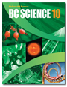
Organic Compounds
Check Your Understanding

Checking Concepts

1. What is organic chemistry the study of?

2. (a) What element do all organic compounds contain?

(b) What other element do most organic compounds contain?

3. Explain why carbon forms so many compounds.

4. Classify each of the following compounds as organic or inorganic by examining their formulas.

(a) CH₃CH₂OH

(b) K₂HC₆H₅O₇

(c) Al₄C₃

(d) C₈H₁₀CH₂OH

(e) CaCO₃

(f) FeCl₂

(g) CH₄

(h) PBr₃

(i) CO₂

(j) C₆H₅COOH

5. What is the definition of a hydrocarbon?

6. (a) What is the chemical name of the simplest hydrocarbon?

(b) What is its common name?

(c) What is it used for?

7. What three elements are present in alcohols?

8. What is the definition of a solvent?

9. What is one use for each of the following?

(a) methanol

(b) ethanol

(c) isopropyl alcohol

10. What is the difference in molecular formula between each of the following pairs?

(a) methane and methanol

(b) ethane and ethanol

(c) propane and isopropyl alcohol

Understanding Key Ideas

11. Classify each of the compounds illustrated as organic or inorganic.

(a)

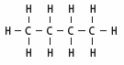

(b)

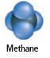

(c)

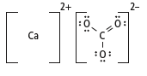

(d) C₅H₁₂

(e) CO₂

(f)

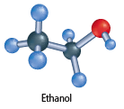



Organic compounds are modelled using molecular formulas, structural formulas, ball-and-stick models, and space-filling models. Which model do you find easier to use? Why? List some advantages and disadvantages of each type of model.

