Section 1.2
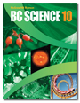
Ecosystems
Check Your Understanding

Checking Concepts

1. List the following terms in order from smallest to largest: biome, biosphere, community, ecosystem, single species, population.

2. How is a habitat different from a niche?

3. Identify which letter represents a biome, which represents a habitat, and which represents an ecosystem in the diagram below.

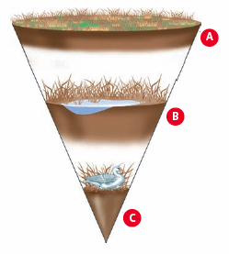
4. What requirements for life are provided by ecosystems?

5. Why is soil important for terrestrial ecosystems?

6. Why are some organisms in an ecosystem in competition?

7. Give one example of a plant adaptation and one example an animal adaptation for:

(a) mutualism

(b) predation

8. Identify each of the following as an example of commensalism, mutualism, parasitism, competition, or predation.

(a) Some bacteria live in roots of soybean plants, obtain sugars from the plant, and provide nitrogen to the plant.

(b) Orchids grow high in the canopy of tropical rainforests. The trees on which the orchids grow are not harmed, nor do they benefit from the orchids.

(c) Tapeworms can live in the intestines of humans. The tapeworm feeds off the nutrients a human host has ingested, making the nutrients unavailable to the host. This can result in malnutrition for the host.

(d) A western red cedar seedling and a Sitka spruce seedling are both growing in a temperate rainforest. Both require sunlight, nutrients, and water from the environment.

(e) Some flowers are pollinated by bats. In return, bats receive nectar from the flowers.

9. Provide several reasons why ecosystems are important to the survival of humans.

Understanding Key Ideas

10. Think about the organisms that live in your community. Identify one example of each of the following.

(a) a competitive relationship

(b) a predator-prey relationship

(c) a commensal relationship

(d) a mutualisitic relationship

11. Many people believe that plants are defenceless. Provide an argument to refute this statement.

12. What will happen when two species compete for the same resources?

13. Describe the effect of the following conditions on a population of predators.

(a) The number of prey animals is low.

(b) The number of prey animals is high.



Suppose a city official recently told reporters “Every type of ecosystem must be preserved.” Consider what you have learned about ecosystems. Use examples from this section to support the statement.

