Section 1.1
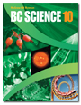
Biomes
Check Your Understanding

Checking Concepts

1. What is the biosphere?

2. List three abiotic components of a biome.

3. What factors influence the characteristics and distribution of life in a terrestrial biome?

4. Explain the importance of adaptations to the survival of plants and animals in their biome.

5. How are plants adapted to survive a short growing season?

6. List two boreal forest animals, and describe their adaptations.

7. Explain why temperate rainforest biomes are found along coastlines.

8. Explain why there is little vegetation on the floor of the tropical rainforest.

9. (a) Identify the biomes shown in the climatographs below.

(b) Explain how you identified each biome.

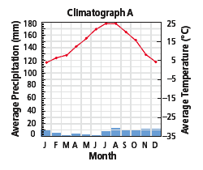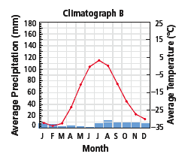

10. Match the following biomes to the descriptions in parts (a) to (g).

(i) tundra  (ii) boreal forest  (iii) temperate deciduous forest  (iv) grassland  (v) tropical rainforest  (vi) desert  (vii) temperate rainforest | (a) distinct seasons, moderate climate  (b) permafrost  (c) Douglas fir, moss, lichen  (d) many layers of trees and plants, but light gets through  (e) great biodiversity, many layers of trees and plants, but light does not get through  (f) fleshy, spiny cacti  (g) coniferous forest

Understanding Key Ideas

11. Explain how latitude influences temperature and precipitation.

12. Explain how temperature affects the biotic component of biomes.

13. Explain why the plants and animals of eastern Canada are similar to the plants and animals of eastern Asia.

14. Distinguish among the three types of adaptations, and provide an example of each type.

15. Imagine that you were travelling directly north from Venezuela near the equator to the North Pole.

(a) List the terrestrial biomes that you would travel through.

(b) Identify one plant and one animal that is typical of each biome.



“The greatest biodiversity is found closest to the equator.” Support or refute (argue against) this statement based on what you have learned in this section.

